Task 1 — Write the Typist Class

Overview
The ‘Typist’ class was implemented to model a single competitor in the typing race.
The class stores identity data (name and symbol), performance data (accuracy), race position (progress), and temporary failure state (burnout and burnout turns remaining).
The implementation follows the coursework method signatures exactly so it remains compatible with ‘TypingRace’.
Encapsulation and Data Safety

Encapsulation in Typist, safeguards data by making all state fields private and forcing external code to interact through controlled public methods.

This prevents outside code from directly assigning invalid values (for example, negative progress or out-of-range accuracy), so the object can enforce its own invariants consistently.

Accessors (getters): getAccuracy(), getProgress(), getName(), getSymbol(), getBurnoutTurnsRemaining(), isBurntOut().

These methods expose current state without modifying it.

Mutators/state-changing methods: setAccuracy(double), setSymbol(char), typeCharacter(), slideBack(int), burnOut(int), recoverFromBurnout(), resetToStart().

These methods change internal state under controlled rules. slideBack(int amount) includes validation by only applying logic when amount > 0, then clamping with Math.max(0, progress - amount).

This guarantees progress never becomes negative, preserving a valid race position. setAccuracy(double newAccuracy) clamps values into [0.0, 1.0] (below 0 becomes 0, above 1 becomes 1).

This matters because accuracy is used as a probability-like value in race mechanics; without clamping, invalid values could produce unrealistic or broken behavior.

Private fields used:
- ‘char typistSymbol’
- ‘String typistName’
- ‘double typistAccuracy’
- ‘int progress’
- ‘boolean isBurntOut’
- ‘int burnoutTurnsRemaining’

Accessors (Getters)
The following methods provide read-only access to internal state:
- ‘getAccuracy()’
- ‘getProgress()’
- ‘getName()’
- ‘getSymbol()’
- ‘getBurnoutTurnsRemaining()’
- ‘isBurntOut()’

Setters / Mutator Methods
The following methods modify state:
- ‘setAccuracy(double newAccuracy)’
- ‘setSymbol(char newSymbol)’
- ‘typeCharacter()’
- ‘slideBack(int amount)’
- ‘burnOut(int turns)’
- ‘recoverFromBurnout()’
- ‘resetToStart()’

Validation Logic
slideBack(int amount)
Uses ‘Math.max(0, progress - amount)’ so progress never drops below zero.
This prevents invalid race states (negative position).
setAccuracy(double newAccuracy)
Clamps input to the valid range ‘[0.0, 1.0]’.
This prevents invalid probability values and keeps race behavior realistic.
Burnout safety (‘burnOut’, ‘recoverFromBurnout’)
Burnout only starts for positive turn values. Recovery decreases turns each cycle and clears burnout exactly when turns reach zero.
This ensures burnout is temporary and deterministic.
resetToStart()
Clears progress and burnout state.
This guarantees typists are reusable for a fresh race without stale state leaking between runs.

Testing Evidence Summary
A dedicated test harness was created and used to validate all required Task 1 conditions.
Executed commands:
(bash)
javac Typist.java TypistTestHarness.java
java TypistTestHarness
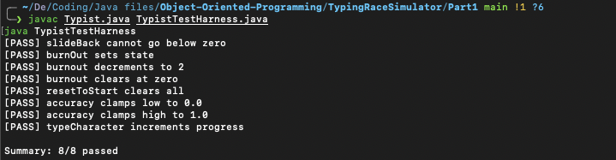
Verified cases:
1. Progress does not go below zero after slideBack().
2. Burnout countdown decreases turn-by-turn and clears at zero.
3. resetToStart() clears progress and burnout state.
4. Accuracy values below 0.0 and above 1.0 are clamped correctly.
5. typeCharacter() advances progress under normal conditions.

Task 2 — Improve the TypingRace Class

